Resume 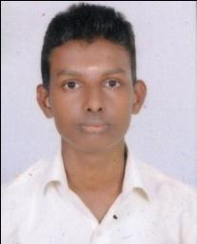
Vijaya kumar. V
s/o Lalitha V
Vanthichal House
Kuntikana (PO) Peradala (Via)
Kasaragod, Kerala (pin)-671 551
Email-vijaykumarkulal001@gmail.com
Mobile no:-09544126001

OBJECTIVE
To work in a high growing, and stimulating working environment that utilizes my skills and abilities in the aids of betterment of organisation and offer sample learning opportunities and bring creative and best in me.
ACADEMIC QUALIFICATION
COURSE | COLLEGE | BOARD OF UNIVERSITY | YEAR OF PASSING
SSLC | MSCHS Nirchal | Kerala board | 2012
P.U.C | GHSS Angadimoger | Kerala Board | 2014
ITI (R&AC egg) | Ideal Technical Institution | Kerala Board | 2016

STRENGTHS
- Hardworking.
- Learning new things.
- Positive thinking.
Computer Skills
- Basic Knowledge
- MS Office
- Internet

PERSONAL PROFILE
Father’s name : Narayana (late)
Mother's name : Lalitha v
Gender : Male
Date of birth : 26th November, 1996
Marital status : single
Languages Known : Tulu, Kannada ,English & Malayalam
Nationality : Indian
Hobbies : Listening Music, Gardening, Reading , watching tv &
playing kabadi.
Work Experience : Fresher

DECLARATION
I do hereby declare that all the Particulars furnished above are true to the best of my knowledge and belief.

(Vijayakumar V)

